St Peter Chanel Catholic School School Board Elections
Parent Elections Results Declaration

Parent representative votes: Name Votes

Burrough, Derek 69

Hall, Marcus 55

Monahan, Philip 57

Rowse, Joel 52

Silverton, Bec 74

Stone, Kelly 47

Invalid Votes 2

I hereby declare the following duly elected:

Derek Burrough
Marcus Hall
Philip Monahan
Joel Rowse
Bec Silverton

Signed
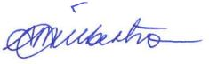
Sarie Gilbertson

Returning Officer

